Tessella Project Number: 7467
Tessella plc 26 The Quadrant, Abingdon Science Park, Abingdon, Oxfordshire, OX14 3YS, UK
T: +44 (0)1235 555511 | F: +44 (0)1235 553301 | E: info@tessella.com | www.tessella.com

Client: STFC & ORNL
Mantid
PM report to Project Management Board
30th November 2012



Document Control
This document is under document control. All members of the distribution list will receive updated copies whenever alterations are made. All other copies are uncontrolled.

Contributors
Name | Role | Company
Nicholas Draper | Author | Tessella

Document Approval
Name | Role | Company

Distribution
Name | Role | Company
Project Management Board Members | Recipient | STFC & ORNL
Mantid Project Repository | Filing | STFC & ORNL

Revision History
Author | Issue | Date | Description
Nicholas Draper | V1.R1.M0 | 27-Nov-2012 | 1st version written

References
Document | Ref | Date | Details and Version
Project Specification | [PS] |  | https://github.com/mantidproject/documents/blob/master/Project%20Management/ProjectSpecification.doc?raw=true
Stakeholder Plan | [SP] |  | https://github.com/mantidproject/documents/blob/master/Project%20Management/StakeholderPlan.doc?raw=true
Risk Register | [RR] |  | https://github.com/mantidproject/documents/blob/master/Project%20Management/RiskRegister.xls

Table of Contents
1 Introduction 4
1.1 Purpose of this Document 4
1.2 Scope of this Document 4
1.3 Context of this Issue 4
2 Project Documentation 4
2.1 Stakeholder Plan: 4
2.2 Risk Register: 4
3 Project Status 4
3.1 Development Progress 4
3.2 Current Development team 6
4 J-PARC request to join the collaboration 7
5 Scientific Computing Strategies (5 year vision) 7
5.1 ISIS (Jon Taylor) 7
5.2 SNS (Mark Hagen) 7
6 Collaborating With Other Facilities 8
6.1 Interest from other institutions 8
7 Financial review 8
8 Future Release Dates 8
9 Appendix A 9
9.1 Project Metrics 9
9.2 Ticket completion rate 10
9.3 Project Uptake 11

Introduction

Purpose of this Document
This report details the current state of the Mantid project and summarises the current plans for further development. The project management board will use the information in this report as a basis for the meeting.

Scope of this Document
The scope of this document is limited to the Mantid project, both for progress up to the meeting of the Project management board, and plans for the future.

Context of this Issue
This is the eighth project management report to the Mantid project management board and will provide input to the meeting.

Project Documentation
The project documentation is available through the links below. The Risk Register has been reviewed and updated. The other documents have not been changed since the last PMB meeting.

Stakeholder Plan:
https://github.com/mantidproject/documents/blob/master/Project%20Management/StakeholderPlan.doc?raw=true
Updates:
Changed Chairman of the PMB to be Toby Perring

Risk Register:
https://github.com/mantidproject/documents/blob/master/Project%20Management/RiskRegister.xls
Updates:
Risk 30: Project internet server fails to provide acceptable performance / reliability – Contingency updated to include transition to jointly managed server dedicated to Mantid

Project Status

Development Progress
Since the last PMB meeting in May 2012 we have completed two development iterations and released new versions of Mantid on the following dates:
- Release 2.2: 13th August 2012
- Release 2.3: 2nd Nov 2012
- Release 2.3.1: 21st Nov 2012
The rate of development within Mantid continued at a fast pace for these two releases; this is supported the project metrics in section 9.2. In particular we have made significant improvements to (among many others):
- User interface
  - ImageViewer
    - Support for both Histogram and event workspaces
    - Including support for direct, indirect and elastic calculation of energy
  - Tof Converter tool
  - Instrument view
    - Unwrapped 2D display without using OpenGL
  - Several usability improvements
- Framework
  - Model Optimisation
    - Support for other inputs such as table workspaces
    - New functions and a new optimizer
    - Instrument fit parameters now survive saving and reloading
    - Resolution Convolution fitting of multi dimensional data
      - Support for the TobyFit Resolution model
  - Live data processing
    - Histogram support for ISIS instruments
    - ADARA support
  - Improved multi-period and grouped workspace handling.
  - Several improvements to Loading and Saving algorithms.
  - Several bug fixes to Masking
  - First release of PSD tube calibration for allowing occlusion based calibration of linear detectors
  - Several algorithms for importing or creating MD workspaces
  - ConvertToMD supports Lorentz correction
- Python
  - SciPy, MatplotLib, nxs, and iPython included in Windows and ubuntu “out of the box”
- Direct Inelastic
  - New implementation of a new inelastic workflow that can preserve events throughout.
  - Together with a new reduction interface
- Indirect Inelastic
  - File finding improved for large directories
  - Several new MIDAS workflow algorithms
  - Improved user interface validation
- SANS
  - Support for merged analysis of both front and rear detector banks, either across the whole range or a selected region of Q.
- Reflectometry
  - ORNL GUI improvements
  - ISIS reflectometry stitching GUI
  - New algorithms for analysis and calibration
- Diffraction
  - Peak workspace addition and subtraction
  - Q space spherical peak integration, improvements to handle edge cases for detectors
  - Improvements to various peak handling algorithms
    - Including support for handling “non-rectangular” detectors
- Muon
  - Support for variable rebinning
  - Change phase angle range to (-pi:+pi) in Muon Oscillating Fit Functions
  - Custom control of start time.
- Support for Ubuntu 12.04
- Support for the VATES extensions on Mac OS X

Current Development team
ISIS | SNS
Nicholas Draper (Tessella, PM) | Stuart Campbell (SNS)
Martyn Gigg (Tessella) | Peter Peterson (SNS)
Roman Tolchenov (Tessella) | Mathieu Doucet (SNS)
Owen Arnold (Tessella) | Russell Taylor (Tessella)
Karl Palmen (STFC) | Michael Reuter (SNS)
Anders Markvardsen (STFC) | Andre Savici (SNS)
Alex Buts (STFC) | Vickie Lynch (SNS)
Gesner Passos (STFC) | Dennis/Ruth Mikkleson (SNS)
Tendaki Kashere (STFC) | Wenduo Zhuo (SNS)
 | Shelly Ren (SNS)
 | Jean Bilheaux (SNS)
 | Jose Borreguero (SNS)
 | Ross Miller (NCCS)
Total FTE: 8+1PM | Total FTE: 6
Not all of the staff on Mantid devote 100% of their time to the Mantid project. So in discussion with group leaders I have provided an estimate of the full time equivalent of the teams from each facility.
Since the last PMB meeting, the ISIS team two student members of the ISIS have left, one student has joined and Gesner has joined as a permanent member. In addition the contribution of 50% of Ronald Fowlers time has ceased. We are currently recruiting one graduate and 4 student positions.

J-PARC request to join the collaboration
Following a visit from one of the J-PARC developers for 3 days before NOBUGS, Robert McGreevey has had an official request from Masa Arai to join the Mantid collaboration. As a project management board we must now consider this request and see how J-PARC could fit into the collaboration.
Items we should discuss:
- Benefits and risks that J-PARC would bring to the collaboration.
- Ways of working with J-PARC to maximise the advantage and minimise the disadvantage of the time difference.
- Are both facilities happy to extend the copyright of existing files to include a third partner?
- Mantid Memorandum of understanding:
Currently it is an agreement between two facilities. I suggest the best solution here is to probably to create a three way MOU for all parties to sign.
  - If we do redraft then I suggest we add a point describing the expected travel between facilities, to include for example 3 developers, or some proportion of the development team for the developer workshop and 2 ad hoc visits to other facilities throughout the year.

The following technical areas will need to be answered, but do not immediately affect the consideration of the request:
- What are the short, medium and long term deployment plans for Mantid?
- What are the short, medium and long term development requirements?
- What level of resource will be assigned to perform these tasks?
- Who will be the lead development contact?
- What operating system environments are important to J-PARC?
- What level of interaction is expected from their instrument scientists?

Scientific Computing Strategies (5 year vision)

ISIS (Jon Taylor)
Presentation by Jon Taylor on the ISIS scientific computing strategy.

SNS (Mark Hagen)
Presentation by Mark Hagen on the SNS scientific computing strategy.

Collaborating With Other Facilities

Interest from other institutions

Reactor Sources

ILL
Ricardo Leal has been looking at the possible data analysis software as part of the evaluation for the NMI3 Data Analysis Standards (WP6). Mantid is one of those he has looked into, and he has visited us for a few days earlier in the year, and for the developer workshop. Other than that it appears his time working directly on Mantid has been limited. His direct feedback to me is that he can clearly see the benefits of the Mantid project, both in the framework itself, but also the team of developers working on it. He was however concerned about how to convince some of the established developers at the ILL.
He will be presenting some of his results on the 5th of November at Garching, at the meeting where a common data analysis package will be chosen for prototyping..

Julich and HDRI
These facilities are part of the NMI3 Data Analysis Standards (WP6) and will be influenced by the outcome of the work being led by the ILL.

ANSTO
David Mannicke is actively looking into Mantid at ANSTO, and is interested in creating a data loader for CDMA based files which would support both ANSTO and SOLEIL files.

Pulsed Neutron sources

ESS
The draft computing strategy for the ESS clearly states that it plans to use Mantid for data reduction and analysis. This has yet to be fully released and approved, and I doubt we will see much movement until the director of the data management and software centre is appointed in the new year.
This together with meetings with Thomas Holm Rod at the ORNL meeting in July and at NOBUGS strongly suggests that this is going to happen. Christian Jacobsen was invited to attend the Mantid developer workshop but pulled out at the last minute for travel budget reasons.

CSNS
No further contact since the last PMB

Financial review
Details of the project financial state is included in Appendix A and B.

Future Release Dates
The planned release dates for the rest of this year would be:
- 1st February 2013
- 3rd May 2013
- 2nd August 2013
- 1st November 2013
This does not include patch releases.

Appendix A

Project Metrics
SubProject | Files | Statements | %comments
Mantid Framework | 3,454 (3,108) | 367,568 (332,874) | 20.1 (19.9)
MantidPlot | 766 (724) | 115,710 (112,862) | 15.8 (15.6)
VATES | 239 (278) | 10,294 (11,782) | 22.5 (21.3)
Total | 4,459 (4,110) | 493,572 (457,518)
The metrics are defined as follows:
Metric | Description
Files | The number of .h, .cpp and *.py files (not including third party libraries) included in the analysis.
Statements | The number of valid C++ statements, loops, conditional statements and pre processor directives are included.
% Comments | This is the percentage of the overall number of lines which are comment lines. I have not directly reported the number of lines in the file, but a good rule of thumb is that it is roughly twice the number of statements.
The Mantid Framework code has significantly grown since the last PMB (the previous values are in brackets), as would be expected with the addition of the new functionality described earlier.

Ticket completion rate
Development on Mantid is performed in three month iterations, each of which ends with an official release of the software. Longer pieces of work sometimes have to span a development iteration in which case that piece of work appears as completed only in the iterations when it becomes available to the users.
The patch releases (2.0.2, 2.1.1 and 2.3.1) are very much smaller and are used to solve issues that become apparent after the main release or release urgent improvements that have recently been added.

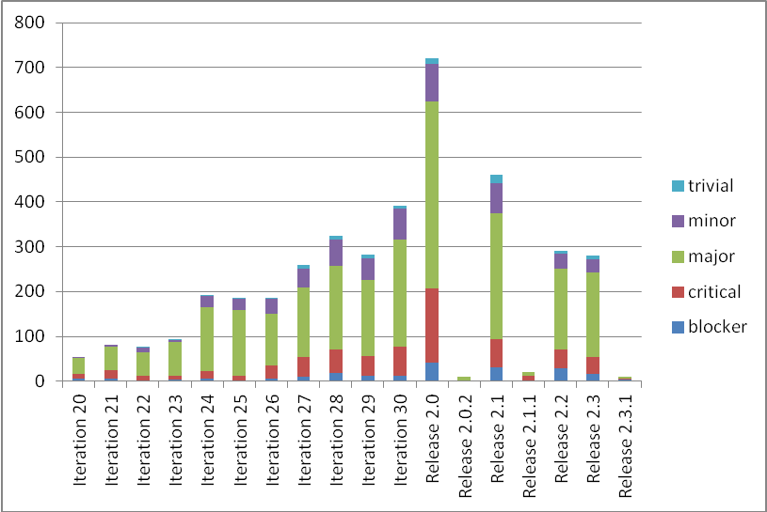

Project Uptake

Mailing List Subscriptions
Our software download site no longer requires people to register to a mailing list in order to download the installer packages. A simple analysis of the email domains shows that while the majority of the users are from ISIS, followed by ORNL and we have had some interest from other institutions and universities.
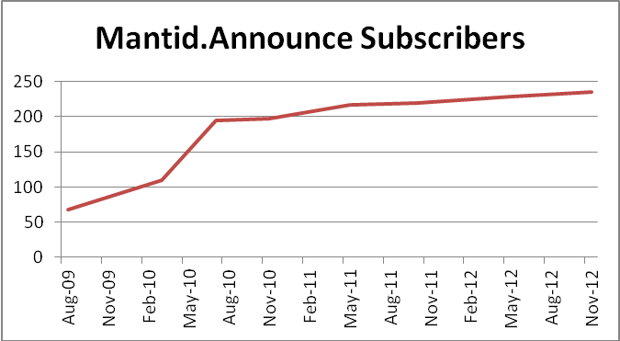
Summary
Date | Users
Aug-09 | 68
Mar-10 | 109
Jul-10 | 195
Nov-10 | 197
May-11 | 217
Oct-11 | 219
May-12 | 228
Nov-12 | 235

Current domain breakdown (2+)
Domain | 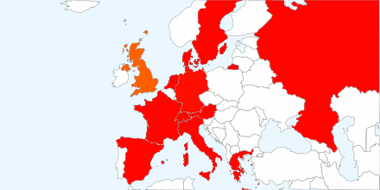  count
stfc.ac.uk | 70
ornl.gov | 28
gmail.com | 22
helmholtz-berlin.de | 9
swansea.ac.uk | 2
sheffield.ac.uk | 2
imperial.ac.uk | 2
caltech.edu | 2
esss.se | 2
owlpic.com | 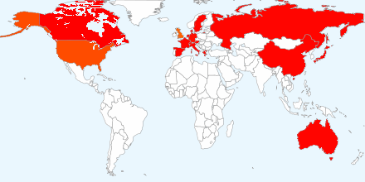  2
tudelft.nl | 2
ill.fr | 2
isc.cnr.it | 2
physics.ox.ac.uk | 2
anl.gov | 2
bath.ac.uk | 2
psi.ch | 2
uwstout.edu | 2
ansto.gov.au | 2
clemson.edu | 2
hmi.de | 2
j-parc.jp | 2
ihep.ac.cn | 2
lanl.gov | 2

Software Downloads
Since December 2010 when we removed the requirement to subscribe to the mailing list, we began to track downloads. We record the ip-address along with the file downloaded, due to the nature of facility users sharing ip-addresses it is not possible to only report on unique ip-addresses, but the total count of downloads is interesting although too much should not be read from it. I should also stress that this does not currently include Unix RPM downloads via the ISIS or SNS Red Hat repositories.

